**Troubleshooting Internet Explorer 11 Compatibility**

If you choose to use Web Form on IE11 or 9, you must enable Compatibility View for all Web sites in Internet Explorer.

To enable Compatibility View for all Web sites, follow these steps:

1. In Internet Explorer 11, from the Tools menu, select Compatibility View Settings.



Note: If the ‘Compatibility View Settings’ option is not available; your network administrator may have used a Group Policy setting to configure the options for you. Contact your system administrator or help desk for more information.

The Compatibility View Settings window opens.

Copy the web Form URL and paste it under “Add this Website” textbox and click on “Add”.

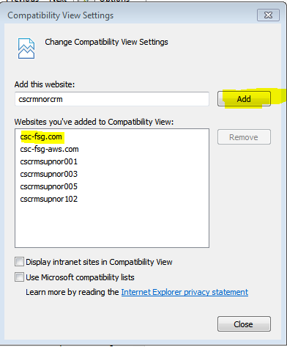

URL : <https://rmx-gwu.csc-fsg.com/GWU/(S(a1d0faervztvjpr132c22vem))/Report.aspx>

Screen 1: Open Website on your Browser. In case it is showing the below error follow below steps to add your website in compatibility view.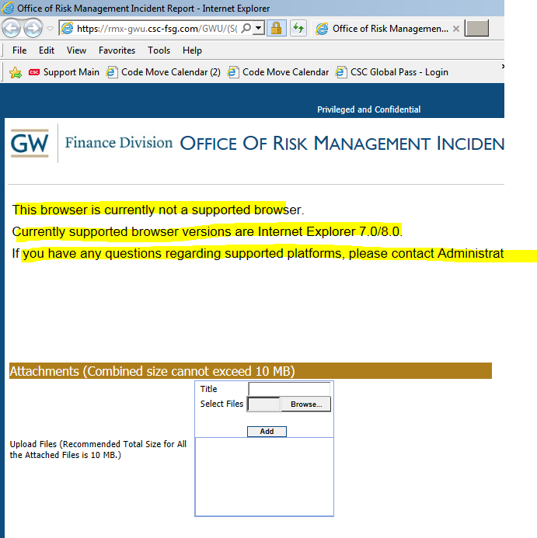

Screen 2: Client on Tools(*) on the Right side of browser.

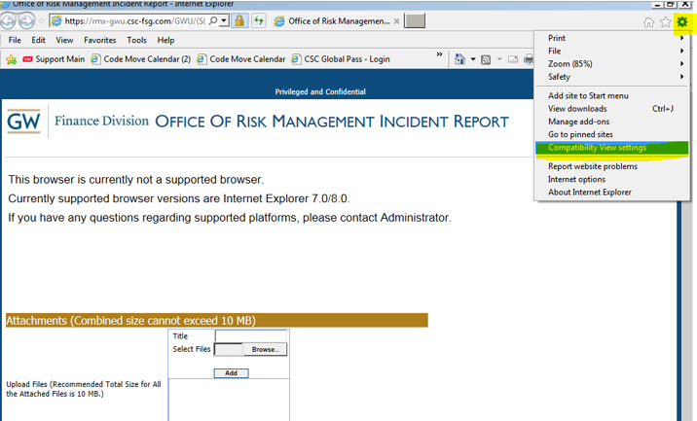

Screen 3: “Compatibility View settings” windows Open ups. Add “csc-fsg.com” domain name on the “Add this Website” text box and click on “Add” button on the screen.

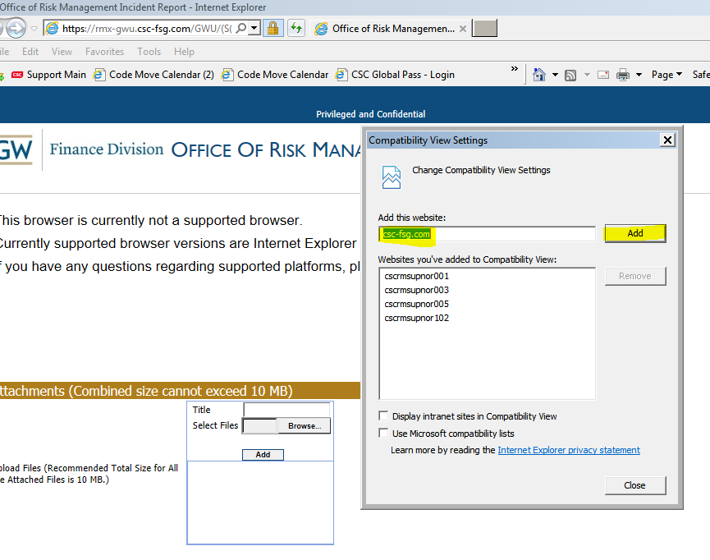

Screen 4: Click on “Close” button

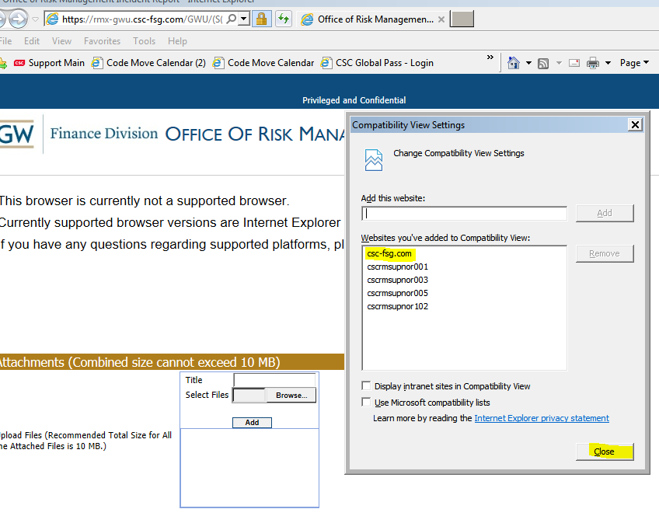

Screen 5: Refresh your website.

